ST. JOHN’S MATRIC HR. SEC. SCHOOL


Melakkal Main Road, Kochadai, Madurai-625 016.

Johnian Anandhavizhuthugal
(St. John’s Staff Alumni Association)

MEMBERSHIP FORM

Name:
Affix recent

Father’s / Husband’s name: ^{photo (passport size)}
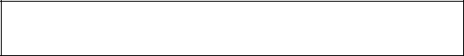

Date of birth: | (DD/MM/YYYY)

Gender:

Blood group:

Mobile no:

Whatsapp no:

E-mail id:

Marital status:

Staffship in school (joined month & year):

Staffship in school (discontinued month & year):

Permanent address:

Educational qualification:

Any other additional information:

Current designation:

Declaration

I certify that the above information furnished by me is correct and true to the best of my knowledge.

President Signature of the Alumni (with date)

